Bar Graph of Scores
Overhead Transparency Bar Graph (1(a)

Different Data Same Box Plot

Overhead Transparency 1b

Instructions for making a box plot
Box plots are based on positions of data points relative to each other for ordered data.

- Order the data.
- Identify the maximum and the minimum.
- Find the median of the ordered data. (If the number of data points is odd, the middle data point is the median; if the number of data points is even, the middle data point is the average of the two middle points
- Find the median of each half of the data: the lower quartile and the upper quartile.
- Plot the five values you have on a number line: minimum, lower quartile, median, upper quartile, and maximum. Connect the minimum to the lower quartile with a line segment. Draw a box determined by the lower and upper quartiles. Put a vertical line through the box at the median. Connect the upper quartile to the maximum with a line segment.
Overhead Transparency 1c
2. How does what you can learn from each plot differ?

a) b)
c) d)
Overhead Transparency Problem 2
A.
Class A Mathematics Scores

50 55 60 65 70 75 80 85 90 95 100
Percent_Correct

B.
Class B Mathematics Scores

50 55 60 65 70 75 80 85 90 95 100
Percent_Correct

C.
Class C Mathematics Scores

50 55 60 65 70 75 80 85 90 95 100
Percent_Correct

Overhead Transparency 5
A)
District X Scores

40 45 50 55 60 65 70 75 80
Sixth_Grade__ Average_Scores

District X Scores

40 45 50 55 60 65 70 75 80
Seventh_Grade_Average_Scores

District X Scores

40 45 50 55 60 65 70 75 80
Eighth_Grade_Average_Scores
B

Overhead Transparency 7

Overhead Transparency 2b
Percentile Plots

Overhead Transparency 2c
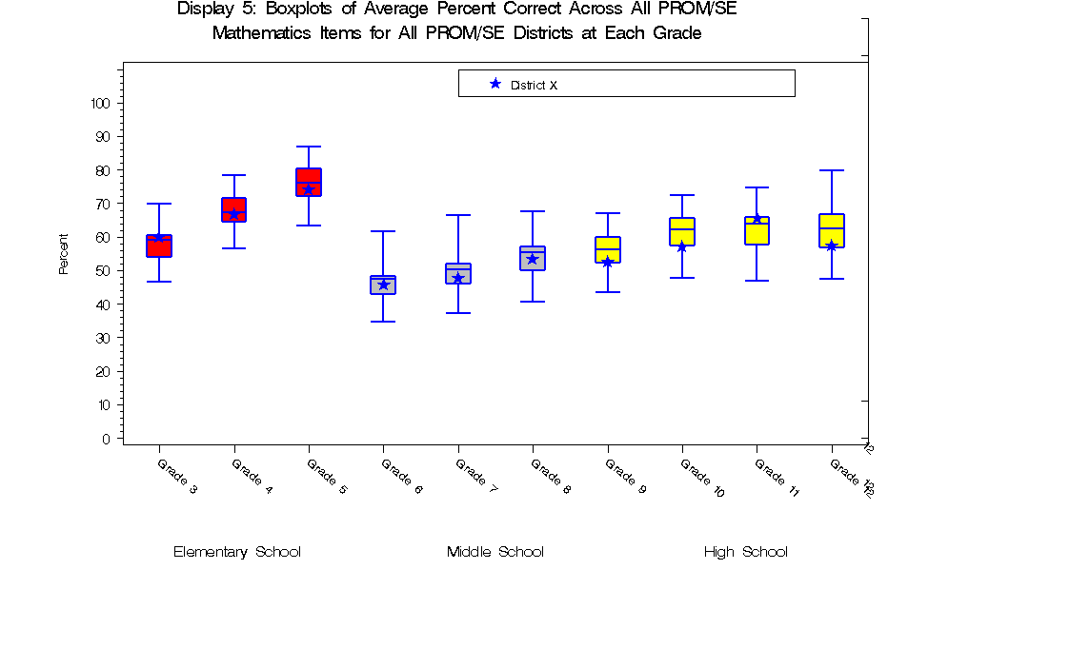
Overhead Transparency 8
y = x
Overhead Transparency 10a

Reflecting on the Activity
- What important statistical concepts are in this activity?

- What does the activity have the potential to reveal about understanding of:
* data analysis content
* problem solving and reasoning
* communication of mathematical ideas

- Where in the curriculum might a teacher want to use an activity like this? What standard/benchmark would this meet? Should the activity be used at different grade levels and if so, how would it be different each time?
Overhead Transparency Reflecting on Activity
How could the problem set be adapted for use with students? What does the activity have the potential to reveal about someone’s understanding of: interpreting data, problem solving and reasoning, and communication about data?

Prior to having students work on a similar problem set, what would the curriculum need to cover so that students would be capable of answering questions such as these successfully?

What might students (or teachers) find “hard” about the activity? What makes it hard?

Overhead Transparency Activity Questions
At what grade level would you expect students to be able to do a
comparable task?” What data concepts would have to come before this and at what grades?

If a student knows the mathematics needed to successfully complete a similar activity, what would be a reasonable set of indicators (expectations) for the next unit of study?
Overhead Transparency Standards’ Questions

Research suggests
Students have trouble moving from specific data points to global descriptors of the data (summarizing statistics)

Introduction of mean and median occurs too early in the curriculum

Mean and median as concepts of center need scaffolding in earlier grades in order to make sense for students.

Sense of distribution as a whole is difficult.

Can do procedures; cannot apply them in context to analyze situation
Overhead Transparency Research
Understandings of Average - Mean

- Exist as normal, typical entity
- Equal sharing
- Balance point
- A number from dividing a sum by the number of values
- Summary value for set of data

These may conflict unless developed carefully

Overhead Transparency Research
Overhead Transparency Research on Mean
What concepts in the activity are addressed in the research?

What do the research findings suggest for the curriculum?

Based on research findings, how might the activity be changed to better enable student learning?

Overhead Transparency Research Questions

